Chemical Equilibrium
Ques(01). Define the following terms:
(i). Irreversible Reactions, (ii). Reversible Reactions, (iii). Chemical Equilibrium

Ques(02). Write down the characteristics of chemical equilibrium.

Ques(03). How many types of chemical equilibrium? Describe them with suitable examples.

(i). Irreversible Reactions:
They are those chemical reactions in which the reactants are completely converted into products, but the products are unable to recombine to give back to the reactants.
Example:
Zn_{(S)} + H²SO⁴_{(aq)} → ZnSO⁴_{(aq)} + H²_{(g)}↑
2KClO³ → 2KCl + 3O²↑

(ii). Reversible Reactions:
The chemical reactions in which reactants can generate the products and products are also able to recombine to form the reactants i.e., they are those reactions which can proceed in both directions.
Examples:
N² + 3H² ↔ NH³
CaCO³ ↔ CaO + CO²
3Fe + 4H²O ↔ Fe³O⁴ + 4H²
2SO² + O² ↔ 2SO³

(iii). Chemical Equilibrium:
The chemical equilibrium is a state in a reversible reaction at which the rate of forward reaction is equal to the rate of backward (reverse) reaction.
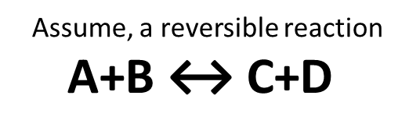
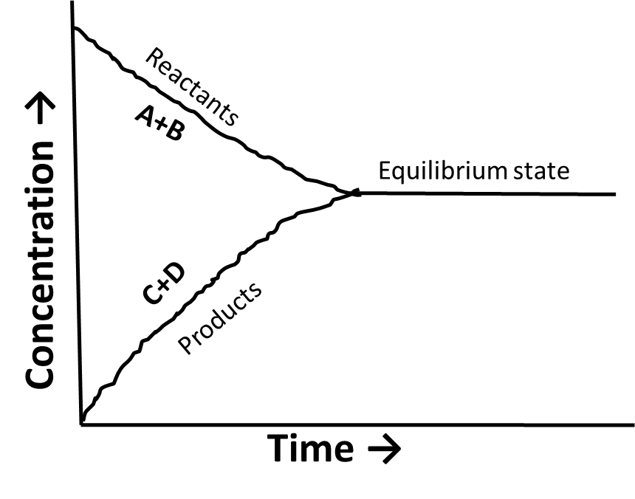

Characteristics of Chemical Equilibrium:
The chemical equilibrium has the following characteristics-
(i). Can only be attained in a closed container,
(ii). Can be established from both sides of the reactions,
(iii). Is dynamic in nature,
(iv). Constancy in properties,
(v). Maximum stability and minimum energy content.

Types of Chemical Equilibrium:
On the nature of the chemical system, the chemical equilibrium is classified into two(2) groups:
(i). Homogeneous Equilibrium: In homogeneous equilibrium the reactants and products are always present in the same phases. e.g.,
H²_{(g)} + Cl²_{(g)} ↔ 2HCl _{(g)}
N²_{(g)} +3H²_{(g)} ↔ 2NH³_{(g)}
2SO² _{(g)} + O²_{(g)} ↔ 2SO³ _{(g)}
C²H⁵OH_{(l)} +CH³COOH _{(l)} ↔CH³COOC²H⁵ _{(l)} + H²O _{(l)}

(ii). Heterogeneous equilibrium:
In heterogeneous equilibrium the reactants and products having different phases.
e.g., CaCO³ ↔ CaO + CO²
AgCl(S) + H₂O(l) ↔AgCl(aq)

Ques(04). What is activity and activity co-efficient?

Activity:
“The experimentally determined value of concentration whether of molecules or ions in solution is less than the actual concentration.” he apparent value of concentration is termed “activity.”
It may be defined as : “The effective concentration of a molecule or ion in a solution.”

Activity Co-efficient (ɣ):
The ratio between the activity, of the effective concentration and actual concentration of the molecule or ion in a solution is defined as activity co-efficient and it is denoted by “ɣ”.
ɣ =$\frac{Effective concentration}{Actual concentration}$= $\frac{a}{c}$
ɣ= a/c or, a= ɣ.c

Ques(05). State and explain law of mass action and deduce it’s mathematical formulation.

Ques(06). Deduce the mathematical formulation of K_{c}, K_{p} and K_{x}.

Law of mass action: Gulberg and waage (1867).
“At constant temperature, the rate of chemical reaction is either directly proportional to the products of the active masses or the partial pressures(for gaseous reactants) of the reacting substances.”
By the term “active mass” is meant the molar concentration and partial pressure.
Explanation:
Let us consider a reaction-
A + B ↔ C + D
In the above reversible reaction, [A] and [B] are the molar concentrations of the reactants A and B respectively. And P^{A} and P^{B} are the partial pressure of the reactants A and B respectively.
Accoring to the law of mass action-
Rate of forward reaction, R^{f} ∞ [A].[B] [For molar concentration]
Rate of forward reaction, R^{f} ∞ P^{A}.P^{B} [For partial pressure]

Mathematical formulation of law of mass action:
Let us consider a general reaction-
A + B ↔ C + D
and let [A], [B], [C] and [D] represent the molar concentration of A, B, C and D at the equiibrium point. According to the law of mass action-

Rate of forward reaction, R^{f} ∞ [A].[B]
R^{f} = K¹ . [A].[B] … … … (i)
Rate of bacward reaction, R^{b} ∞ [C].[D]
R^{b} = K² . [C].[D] … … … (ii)
[Where, K¹ and K² are rate constant for the forward and backward reactions]
At equilibrium, Rate of forward reaction = Rate of backward reaction
Therfore, K₁ . [A].[B] = K₂ . [C].[D]

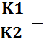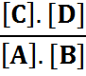
K_{C} = $\frac{\left[C\right]. [D]}{\left[A\right]. [B]}$

At any specific temperature K₁/K₂ is constant since both K₁ and k₂ are constants. The ratio K₁/K₂ is called equilibrium constant and is represented by the symbol “K_{C}” or simply “K”.
At common reversible reaction,
aA + bB + … … .. ↔ lL + mM + … … ..
Equilibrium constant, K_{c} =$\frac{\left[L\right]l \left[M\right]m … …}{\left[A\right]a \left[B\right]b … … }$ … … ..(i)
If the above common equation is gaseous, then active mass means partial pressure. At this, equilibrium constant is denoted by K_{p}.

Equilibrium constant,
K^{P}=P^{L}_{l} ×P^{M}_{m} ×…/ P^{A}_{a} × P^{B}_{b}… …. … ….(ii)
If active mass is expressed by mole fraction, then equilibrium constant is denoted by K^{X} K^{X} = X^{L}_{l} × X^{M}_{m}… /X^{A}_{a} X^{B}_{b}.. ….. …. …(iii)
Eqn (i),(ii) and (iii) are the mathematical formulations of law of mass action.

Ques(07). Establish the relationship between K_{p} and K_{c} .

Ques(08). Establish the relationship between K_{c} and K_{x}.

Ques(09). Establish the relationship between K_{c} , K_{p} and K_{x}.

Relationship between K_{p} and K_{c}
Let us consider a general reaction,
aA + bB ↔ lL + mM
If in the above reaction, all products and reactants are gases, active masses are expressed by partial pressures and the equilibrium constant is denoted by K_{P}. So, at the above common reaction-
K^{P}=P^{L}_{l} ×P^{M}_{m}/ P^{A}_{a} × P^{B}_{b} …. … ….(i)
Again, if active masses of all the products and reactants are expressed by molar concentrations, then equilibrium constant is denoted by K^{c}
K^{c} = $\frac{\left[L\right]l \left[M\right\}m … …}{\left[A\right]a \left[B\right]b … …}$ … … ... (ii)
Now, if partial pressure of “n” mole any gas of the ideal gas mixture is P, temperature T and total volume V, then according to ideal gas law-
PV= nRT
P = RT
P=CRT [Here, =C= molar concentration ]
If P^{A} , P^{B} , P^{L} and P^{M} are the partial pressures of A ,B , L , and M, then we get, P^{A}= C^{A}RT, P^{B}=C^{B}RT, P^{L}=C^{L}RT, P^{M}=C^{M}RT. Then, substituting the value of P in equation (i) we get,

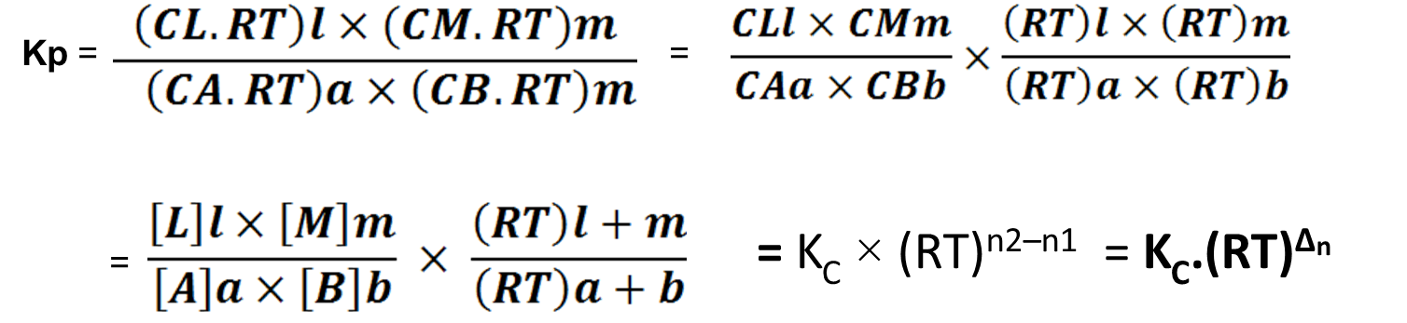

If the total mole no of reacting species and that of products be equal, then the difference of mole no, ∆n=0
Therefore, K_{p}=K^{C}.(RT)₀ = K^{C}
K_{p} =K^{C}
Relationship between K_{c} and K_{x}

For the gaseous reversible reaction,P_{A}ª ×P_{B}^{b}
aA_{(g)} + bB_{(g)} ↔ lL_{(g)} + mM_{(g)}

We get, equilibrium const, Kp=$\frac{PLl PMm }{PAa PBb }$ … … … (i)
We know that ,Partial pressure = Mole fraction ×Total pressure.
P = x.P
Let, Total pressure=P, Partial pressure =p and mole fraction =x
Then,we get partial pressure of A, B, L and M are p_{A} = x_{A}.P , p_{B} = x_{B}.P , p_{L} = x_{L}.P , p_{M} = x_{M}.P respectly.

Substituting the value of p_{A}, p_{B}, p_{L} and p_{M} in equation (i), we get,
K_{P} = $\frac{\left(xL.P\right)l \left(xM.P\right)m}{\left(xA.P\right)a \left(xB.P\right)b}$
= $\frac{xLl . xMm}{xAa . xBb}$ × $\frac{Pl .Pm}{Pa . Pb}$
=K_{x} × $\frac{P(l+m)}{P(a+b)}$
= K_{x} × P^{(l+m) −(a+b)}
= K_{x} . P^{Δn}
K_{P} = K_{x} . P^{Δn}
….. …. …. (ii)
K_{P} = K_{C} . (RT)^{Δn}
Again we know, …. …. …. (iii)

Equating eq^{n} (i) and eq^{n} (ii) we get,
K_{C} . (RT)^{Δn} = K_{x} . P^{Δn}
K_{C} = K_{x} . (P/RT)^{Δn}
K_{C} = K_{x} . (1/V)^{Δn}
K_{X} = K_{C} . V^{Δn}
…. …. …. (iv)

If the difference of total mole no. be zero, then Δn = 0
Therefore, K_{X} = K_{C} . V⁰

K_{X} = K_{C}

Relationship between K_{p}, K_{c} and K_{x}:
If the difference of total mole number of products and reactants is zero, i.e., Δn = 0 we get,
K_{p}= K^{C}.(RT)_{Δn} = K^{C}.(RT)₀ = K^{C}
K_{p}= K^{x}.(P)_{Δn} = K^{x}.(P)₀ = K^{x}
K_{x}= K^{C}.(V)_{Δn} = K^{C}.(V)₀ = K^{C}
K_{p} = K_{c} = K_{x}.

This is the relationship between K_{p} , K_{c} and K_{x}.

Ques(10). State and explain the Le-Chatelier’s principle.
Or, Explain the effect of change of temperature , pressure, concentration and catalyst on equilibrium.

Ques(11). Write down the applications of “Le-Chatelier’s principle” to physical equilibrium.

Ques(12). What is active mass?

Le-Chatelier’s principle:

“When an equilibrium is subjected to either a change in temperature or a change in external pressure or a change in concentration , the equilibrium will shift in that direction where the effects caused by these changes are reduced.”

Explanation:

(1). Effet of change of temperature: There are 3 types of chemical equilibrium:
(i). aA + bB ⇔ mC + nD + Q. (exothermic)
(ii). aA + bB + Q ⇔ mC + nD. (endothermic)
(iii). aA + bB ⇔ mC + nD.

(i). Exothermic equilibrium: Rate of reaction decreases with the increases in temperature.
Exam: N₂ _{(g)} + O_{2 (g)} ⇔ 2NH₃ _{(g)} + 93.74 KJ

(ii). Endothermic equilibrium: Rate of reaction increases with the increase in temperature.
Exam: N₂ _{(g)} + O_{2 (g)} + 180.75 KJ ⇔ 2NO _{(g)}

(iii). If the reaction has no change in temperature, then there have no effect of temperature.

(2). Effect of change of pressure: The effect of change of pressure on chemical equilibrium is given by the following expression:

K_{p}= K^{x}.(P)_{Δn}

(i). When Δn = 0, K_{p}= K^{x}.(P)_{Δn} = K^{x}.(P)₀ = K^{x}
This type of equilibrium is always independent of the external pressure change. For example,
H₂ + I₂ ⇔ 2HI
C₂H₅OH + CH₃COOH ⇔ CH₃COOC₂H₅ + H₂O
N₂ + O₂ ⇔ 2NO
(ii). When Δn = −Ve , K_{p}= K^{x}.(P)_{−Δn} = K^{x}/(P)_{Δn}
In this case, the increase in external pressure will shift the equilibrium towards forward direction to maintain the K_{p}.
Similarly , decrease in external pressure will shift the equilibrium in the reverse direction.
Exam: N₂ + 3H₂ ⇔ 2NH₃ ; Δn = −2
PCl₃ + Cl₂ ⇔ PCl₅ ; Δn = −1
2SO₂ + O₂ ⇔ 2SO₃ ; Δn = −1

(iii). When Δn = +Ve , K_{p}= K^{x}.(P) _{Δn} = K^{x}P_{Δn}
The increase in pressure will shift the equilibrium towards reverse direction to maintain the K_{p}.
Similarly , the decrease in external pressure will shift the equilibrium towards the forward direction.
Exam: 2NH₃ ⇔ N₂ + 3H₂ ; Δn = +2
PCl₅ ⇔ PCl₃ + Cl₂ ; Δn = +1
2SO₃ ⇔ 2SO₂ + O₂ ; Δn = +1

(3). Effect of change of concentration:
Assume a general reaction,
aA + bB ⇔ mC + nD
The equilibrium constant of this equilibrium at a given temperature will be ,
Kc = $\frac{\left[C\right]m \left[D\right]n}{\left[A\right]a \left[B\right]b}$

(A). Concentration of reactant :
(i). Increases → Equilibium shift in R.H.S.
→ More products.
(ii). Decreases → Equilibium shift in L.H.S.
→ Product decreases.

(B). Concentration of produccs:
(i). Increases → Equilibrium shifts towards L.H..S.
→ Reatants increase

(ii). Decrease → Equilibrium shifts towards R.H..S.
→ Products increase.

(4). Effet of catalyst on equilibrium :
Science, the catalyst is associated with rate of reaction and at equilibrium, r₁=r₂ and so the catalyst will affect both the rates equally. Hence, this will never affect the point of equilibrium.

Applications of Le Chatelier’s principle to physical equilibrium:

(i). Melting point of a solid:
At melting point, the following equilibria will exist.
Solid ⇔ Liquid
⇒Increase in temperature will shift the equilibria in the forward direction. [Because it is endothermic process].
⇒Increase in pressure will decrease the melting point.

(ii). Solubility of salt:
In some of the cases, the solubilities are accompanied by the absorption of heat i.e,. cooling results.
Exam: NH₄Cl + Q ⇔ NH₄⁺ _{(aq)} + Cl⁻_{(aq)}
AgCl +Q ⇔ Ag⁺ _{(aq)} + Cl⁻ _{(aq)}.

Hence, the increase in temperature will shift the equilibrium in the forward direction, increasing solubility.
When the solubility is accompanied by the release of heat, i.e.,
(CH₃COO)₂Ca ⇔ 2 CH₃COO⁻ _{(aq)} + Ca²⁺ _{(aq)} + Q
In this case, the increase in temperature will shift the equilibrium towards reverse direction i.e.,the solubility will decrease.

Active mass:
Active mass of reactants /products, a=c.f
Here, c = molar concentration
f = activity co-efficient
In single phase, homogeneous solution (gas solution), a=c
Active mass = Molecular concentration.

Some Problems
Prob(01). Calculate the active mass of 4 gm of NaOH dissolved in 250 cc solution.

Prob(02). Calculate the active mass of 12.7 gm of I₂ in 2 Litres of the reaction vessel.

Prob(03). Calculate the partial pressure of N₂ in a container when 3 moles of nitrogen(N₂) and 6 moles of chlorine(Cl₂) gas are present. The total pressure exerted by the mixture is 2 atm.

Prob(04). Calculate the partial pressure of each component in the following equilibria:
N₂ + 3H₂ ↔ 2NH₃

Prob(05). The equilibrium constant for the reaction,
PCl₅ _{(g)} ↔ PCl₃ _{(g)} + Cl₂ _{(g)} is 2.4 ×10⁻³.
Determine the…

